Analysis Report
Assignment 5
We are interested in variety of selected features in the response of variable Bush in election2000.csv data, the percentage of a state’s total counted vote that was for George Bush in the 2000 presidential election, based on a subset of the following independent variables:
UnE = the unemployment rate for the state
Pop = the total state population
Male = the proportion of males in the state
Male18 = the proportion of males older than 18
Pop65 = the proportion of the population older than 65
NonMet = the proportion of rural (non metro) population
Pov = the proportion of the population below the poverty rate
NuHouse = the total number of households
Inc50 = the proportion of households earning more than $50,000
Inc75 = the proportion of households earning more than $75,000
Inc100 = the proportion of households earning more than $100,000

1. Fit a multivariate linear regression with all predictors (model 1). Report the fitted model, and the corresponding adjusted R-square, AIC, BIC. Present the predictors which does not have significant impact on the dependent variable Bush given 0.05 significance level.
Step 1: Fit a multivariate linear regression with all predictors
Step 2: Reporting information
OLS Regression Results
==============================================================================
Dep. Variable: Bush R-squared: 0.815
Model: OLS Adj. R-squared: 0.755
Method: Least Squares F-statistic: 13.61
Date: Tue, 24 Feb 2026 Prob (F-statistic): 1.89e-09
Time: 19:23:42 Log-Likelihood: -133.98
No. Observations: 46 AIC: 292.0
Df Residuals: 34 BIC: 313.9
Df Model: 11
Covariance Type: nonrobust
==============================================================================
coef std err t P>|t| [0.025 0.975]
------------------------------------------------------------------------------
const -652.3175 191.613 -3.404 0.002 -1041.722 -262.913
UnE -2.0342 1.147 -1.774 0.085 -4.365 0.297
Pop -3.453e-07 5.78e-07 -0.598 0.554 -1.52e-06 8.29e-07
Male 54.3664 14.425 3.769 0.001 25.051 83.682
Male18 -40.3098 11.056 -3.646 0.001 -62.779 -17.841
Pop65 -1.2891 0.543 -2.373 0.023 -2.393 -0.185
NonMet 0.2218 0.059 3.788 0.001 0.103 0.341
Pov 0.2802 0.508 0.552 0.585 -0.752 1.312
NuHouse 1.498e-06 1.65e-06 0.909 0.370 -1.85e-06 4.85e-06
Inc50 -0.0557 0.661 -0.084 0.933 -1.399 1.288
Inc75 0.0249 1.666 0.015 0.988 -3.361 3.411
Inc100 -1.2586 2.106 -0.598 0.554 -5.538 3.021
==============================================================================
Omnibus: 0.436 Durbin-Watson: 2.386
Prob(Omnibus): 0.804 Jarque-Bera (JB): 0.549
Skew: 0.204 Prob(JB): 0.760
Kurtosis: 2.654 Cond. No. 2.12e+09
==============================================================================

Notes:
[1] Standard Errors assume that the covariance matrix of the errors is correctly specified.
[2] The condition number is large, 2.12e+09. This might indicate that there are
strong multicollinearity or other numerical problems.

The fitted regression equation is:
- Bush = -652.3175 – 2.0342UnE – 3.453*10⁻⁷ Pop + 54.3664Male – 40.3098Male18 – 1.2891Pop65 + 0.2218NonMet + 0.2802Pov + 1.498*10⁻⁶NuHouse – 0.0557Inc50 + 0.0249Inc75 – 1.2586Inc100
Model Statistics:
- R-squared adjusted: 0.755
- AIC: 292.0
- BIC: 313.9
The predictors which are not significant in predicting the response value Bush with p-value greater than 0.05 are: UnE, Pop, Pov, NuHouse, Inc50, Inc75, Inc100

2. Apply best subset approach for variable selection (model 2). We choose BIC as our criterion. Present which features are selected in the final model. Also report the fitted model, and the corresponding adjusted R-square, AIC, BIC.
Step 1: Define the function fit_lm() with the input as a set of selected features and output be the fitted model with corresponding RSS, R-squared adjusted, AIC, and BIC.
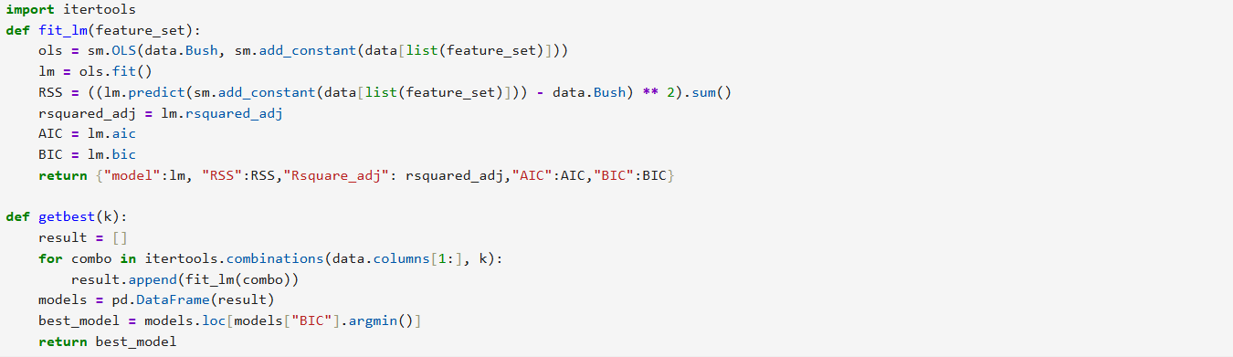
Step 2: Define the function getbest() with the unput as the number of the selected features and the output as the best model given the pre-specified number of features. The best model refers to the one with lowest BIC as they are all equally complicated

Step 3: Find the best model with 1-12 features, and report corresponding RSS, R-squared adj, AIC, BIC
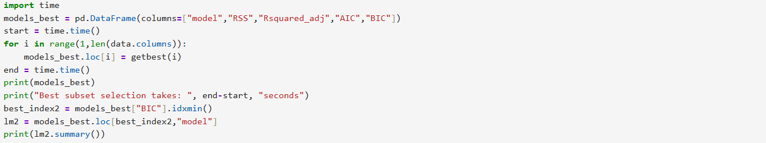
model RSS \
1 <statsmodels.regression.linear_model.Regressio... 2969.238063
2 <statsmodels.regression.linear_model.Regressio... 2166.632919
3 <statsmodels.regression.linear_model.Regressio... 1384.370173
4 <statsmodels.regression.linear_model.Regressio... 1166.068477
5 <statsmodels.regression.linear_model.Regressio... 1052.406013
6 <statsmodels.regression.linear_model.Regressio... 986.58975
7 <statsmodels.regression.linear_model.Regressio... 937.245641
8 <statsmodels.regression.linear_model.Regressio... 922.92846
9 <statsmodels.regression.linear_model.Regressio... 912.863033
10 <statsmodels.regression.linear_model.Regressio... 912.467606
11 <statsmodels.regression.linear_model.Regressio... 912.461597

Rsquared_adj AIC BIC
1 NaN 326.243631 329.900914
2 NaN 313.747602 319.233526
3 NaN 295.142867 302.457432
4 NaN 289.248923 298.39213
5 NaN 286.531217 297.503065
6 NaN 285.560539 298.361028
7 NaN 285.200329 299.829461
8 NaN 286.49222 302.949993
9 NaN 287.98779 306.274204
10 NaN 289.96786 310.082915
11 NaN 291.967557 313.911254
Best subset selection takes: 9.368871688842773 seconds
OLS Regression Results
==============================================================================
Dep. Variable: Bush R-squared: 0.787
Model: OLS Adj. R-squared: 0.760
Method: Least Squares F-statistic: 29.48
Date: Thu, 26 Feb 2026 Prob (F-statistic): 2.02e-12
Time: 12:08:07 Log-Likelihood: -137.27
No. Observations: 46 AIC: 286.5
Df Residuals: 40 BIC: 297.5
Df Model: 5
Covariance Type: nonrobust
==============================================================================
coef std err t P>|t| [0.025 0.975]
------------------------------------------------------------------------------
const -717.4821 146.570 -4.895 0.000 -1013.712 -421.252
Male 60.5757 12.043 5.030 0.000 36.236 84.916
Male18 -45.3635 9.428 -4.811 0.000 -64.419 -26.308
Pop65 -1.0359 0.491 -2.110 0.041 -2.028 -0.043
NonMet 0.1794 0.044 4.089 0.000 0.091 0.268
Inc100 -1.7905 0.539 -3.324 0.002 -2.879 -0.702
==============================================================================
Omnibus: 0.327 Durbin-Watson: 2.305
Prob(Omnibus): 0.849 Jarque-Bera (JB): 0.353
Skew: 0.184 Prob(JB): 0.838
Kurtosis: 2.780 Cond. No. 1.51e+04
==============================================================================

Notes:
[1] Standard Errors assume that the covariance matrix of the errors is correctly specified.
[2] The condition number is large, 1.51e+04. This might indicate that there are
strong multicollinearity or other numerical problems.

The Male, Male18, Pop65, NonMet, and Inc100 features are selected in the final model, with the all p-values are 0.000, indicating they are significant in this model to predict Bush variable.
The fitted regression equation is:
- Bush = -717.4821 + 60.5757Male – 45.3635Male18 – 1.0359Pop65 + 0.1794NonMet – 1.7905Inc100
Model Statistics:
- R-squared adjusted: 0.760
- AIC: 286.5
- BIC: 297.5
3. Apply forward approach for variable selection (model 3). We choose BIC as our criterion. Present features are selected in the final model. Also report the fitted model, and the corresponding adjusted R-square, AIC, BIC.
Step 1: Create two lists to add each feature each time and assign starting time of function
Step 2: Construct forward approach for variable selection
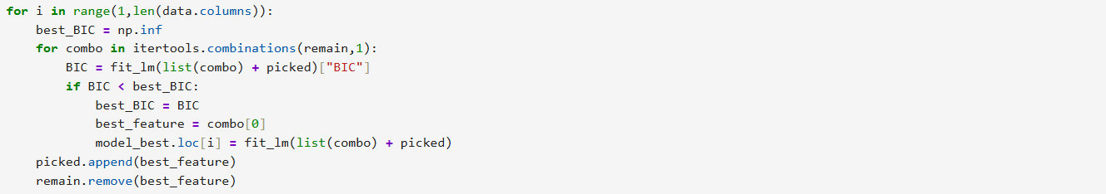
Step 3: Assign ending time and display information on the screen
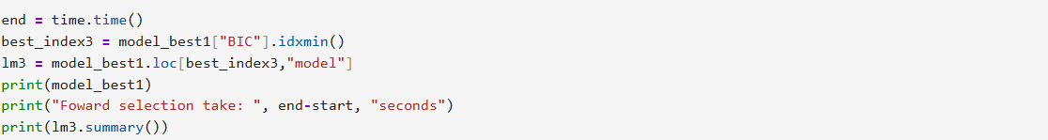
model RSS \
1 <statsmodels.regression.linear_model.Regressio... 2969.238063
2 <statsmodels.regression.linear_model.Regressio... 2356.629542
3 <statsmodels.regression.linear_model.Regressio... 1384.370173
4 <statsmodels.regression.linear_model.Regressio... 1166.068477
5 <statsmodels.regression.linear_model.Regressio... 1060.690673
6 <statsmodels.regression.linear_model.Regressio... 986.589750
7 <statsmodels.regression.linear_model.Regressio... 938.527163
8 <statsmodels.regression.linear_model.Regressio... 928.362027
9 <statsmodels.regression.linear_model.Regressio... 922.062471
10 <statsmodels.regression.linear_model.Regressio... 912.651987
11 <statsmodels.regression.linear_model.Regressio... 912.461597

Rsquared_adj AIC BIC
1 NaN 326.243631 329.900914
2 NaN 317.614276 323.100200
3 NaN 295.142867 302.457432
4 NaN 289.248923 298.392130
5 NaN 286.891916 297.863765
6 NaN 285.560539 298.361028
7 NaN 285.263184 299.892315
8 NaN 286.762242 303.220015
9 NaN 288.449038 306.735452
10 NaN 289.977154 310.092209
11 NaN 291.967557 313.911254
Foward selection take: 0.5218911170959473 seconds

OLS Regression Results
==============================================================================
Dep. Variable: Bush R-squared: 0.785
Model: OLS Adj. R-squared: 0.758
Method: Least Squares F-statistic: 29.19
Date: Thu, 26 Feb 2026 Prob (F-statistic): 2.35e-12
Time: 12:08:08 Log-Likelihood: -137.45
No. Observations: 46 AIC: 286.9
Df Residuals: 40 BIC: 297.9
Df Model: 5
Covariance Type: nonrobust
==============================================================================
coef std err t P>|t| [0.025 0.975]
------------------------------------------------------------------------------
const -775.2704 141.775 -5.468 0.000 -1061.809 -488.732
Pop65 -0.9741 0.489 -1.993 0.053 -1.962 0.013
NonMet 0.1785 0.044 4.029 0.000 0.089 0.268
Male 64.6501 11.764 5.495 0.000 40.874 88.426
Male18 -48.3254 9.239 -5.231 0.000 -66.998 -29.652
Inc75 -0.7769 0.238 -3.263 0.002 -1.258 -0.296
==============================================================================
Omnibus: 0.114 Durbin-Watson: 2.276
Prob(Omnibus): 0.945 Jarque-Bera (JB): 0.281
Skew: 0.094 Prob(JB): 0.869
Kurtosis: 2.666 Cond. No. 1.46e+04
==============================================================================

Notes:
[1] Standard Errors assume that the covariance matrix of the errors is correctly specified.
[2] The condition number is large, 1.46e+04. This might indicate that there are
strong multicollinearity or other numerical problems.
The Pop65, NonMet, Male, Male18, Inc75 features are selected in the final model, with the p-value are
less than 0.05 - except Pop65 is marginally insignificant at the 0.05 level, indicating they are significant in this model to predict Bush variable.

The fitted regression equation is:
- Bush = -775.2704 – 0.9741Pop65 + 0.1785NonMet + 64.6501Male – 48.3254Male18 – 0.7769Inc75
Model Statistics:
- R-squared adjusted: 0.758
- AIC: 286.9
- BIC: 297.9
4. Apply backward approach for variable selection (model 4). We choose BIC as our criterion. Present features are selected in the final model and report the fitted model, and the corresponding adjusted R-square, AIC, BIC.
Step 1: Create a list to remove a feature each time and assign starting time of function
Step 2: Construct backward approach for variable selection
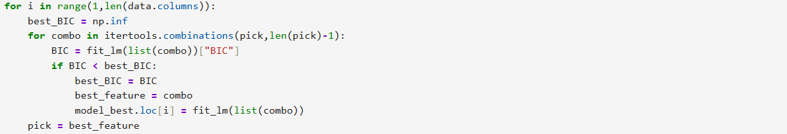
Step 3: Assign ending time and display information on the screen
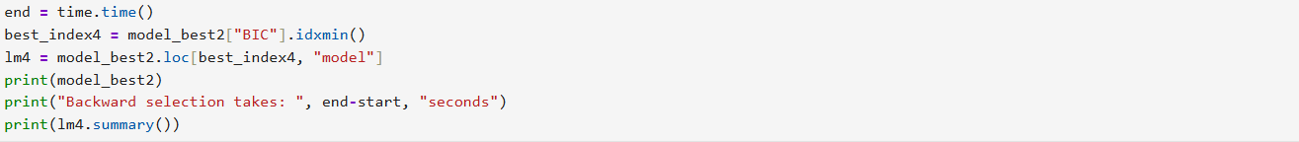
model RSS \
1 <statsmodels.regression.linear_model.Regressio... 912.467606
2 <statsmodels.regression.linear_model.Regressio... 912.863033
3 <statsmodels.regression.linear_model.Regressio... 922.928460
4 <statsmodels.regression.linear_model.Regressio... 937.245641
5 <statsmodels.regression.linear_model.Regressio... 987.109192
6 <statsmodels.regression.linear_model.Regressio... 1052.406013
7 <statsmodels.regression.linear_model.Regressio... 1169.495053
8 <statsmodels.regression.linear_model.Regressio... 1384.370173
9 <statsmodels.regression.linear_model.Regressio... 2348.014847
10 <statsmodels.regression.linear_model.Regressio... 3568.421052
11 <statsmodels.regression.linear_model.Regressio... 4930.727765

Rsquared_adj AIC BIC
1 NaN 289.967860 310.082915
2 NaN 287.987790 306.274204
3 NaN 286.492220 302.949993
4 NaN 285.200329 299.829461
5 NaN 285.584751 298.385241
6 NaN 286.531217 297.503065
7 NaN 289.383899 298.527106
8 NaN 295.142867 302.457432
9 NaN 317.445814 322.931738
10 NaN 334.699252 338.356534
11 NaN 347.573967 349.402609
Backward selection takes: 0.4330761432647705 seconds

OLS Regression Results
==============================================================================
Dep. Variable: Bush R-squared: 0.787
Model: OLS Adj. R-squared: 0.760
Method: Least Squares F-statistic: 29.48
Date: Thu, 26 Feb 2026 Prob (F-statistic): 2.02e-12
Time: 12:08:08 Log-Likelihood: -137.27
No. Observations: 46 AIC: 286.5
Df Residuals: 40 BIC: 297.5
Df Model: 5
Covariance Type: nonrobust
==============================================================================
coef std err t P>|t| [0.025 0.975]
------------------------------------------------------------------------------
const -717.4821 146.570 -4.895 0.000 -1013.712 -421.252
Male 60.5757 12.043 5.030 0.000 36.236 84.916
Male18 -45.3635 9.428 -4.811 0.000 -64.419 -26.308
Pop65 -1.0359 0.491 -2.110 0.041 -2.028 -0.043
NonMet 0.1794 0.044 4.089 0.000 0.091 0.268
Inc100 -1.7905 0.539 -3.324 0.002 -2.879 -0.702
==============================================================================
Omnibus: 0.327 Durbin-Watson: 2.305
Prob(Omnibus): 0.849 Jarque-Bera (JB): 0.353
Skew: 0.184 Prob(JB): 0.838
Kurtosis: 2.780 Cond. No. 1.51e+04
==============================================================================

Notes:
[1] Standard Errors assume that the covariance matrix of the errors is correctly specified.
[2] The condition number is large, 1.51e+04. This might indicate that there are
strong multicollinearity or other numerical problems.

The Male, Male18, Pop65, NonMet, and Inc100 features are selected in the final model, with the all p-values are 0.000, indicating they are significant in this model to predict Bush variable.
The fitted regression equation is:
- Bush = -717.4821 + 60.5757Male – 45.3635Male18 – 1.0359Pop65 + 0.1794NonMet – 1.7905Inc100
Model Statistics:
- R-squared adjusted: 0.760
- AIC: 286.5
- BIC: 297.5
5. Apply forward approach for variable selection. This time, we determine the best model based on K-fold cross validation (you can decide the value of K) (model 5). Present features are selected in the final model and please report the fitted model, and the corresponding adjusted R-square, AIC, BIC.
Step 1: Get result from forward approach in question 3 stored in variable model_best1
Step 2: Using K-fold cross validation
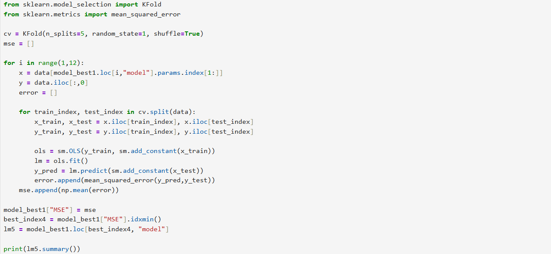
Step 3: Present OLS table
OLS Regression Results
==============================================================================
Dep. Variable: Bush R-squared: 0.785
Model: OLS Adj. R-squared: 0.758
Method: Least Squares F-statistic: 29.19
Date: Thu, 26 Feb 2026 Prob (F-statistic): 2.35e-12
Time: 12:08:08 Log-Likelihood: -137.45
No. Observations: 46 AIC: 286.9
Df Residuals: 40 BIC: 297.9
Df Model: 5
Covariance Type: nonrobust
==============================================================================
coef std err t P>|t| [0.025 0.975]
------------------------------------------------------------------------------
const -775.2704 141.775 -5.468 0.000 -1061.809 -488.732
Pop65 -0.9741 0.489 -1.993 0.053 -1.962 0.013
NonMet 0.1785 0.044 4.029 0.000 0.089 0.268
Male 64.6501 11.764 5.495 0.000 40.874 88.426
Male18 -48.3254 9.239 -5.231 0.000 -66.998 -29.652
Inc75 -0.7769 0.238 -3.263 0.002 -1.258 -0.296
==============================================================================
Omnibus: 0.114 Durbin-Watson: 2.276
Prob(Omnibus): 0.945 Jarque-Bera (JB): 0.281
Skew: 0.094 Prob(JB): 0.869
Kurtosis: 2.666 Cond. No. 1.46e+04
==============================================================================

Notes:
[1] Standard Errors assume that the covariance matrix of the errors is correctly specified.
[2] The condition number is large, 1.46e+04. This might indicate that there are
strong multicollinearity or other numerical problems.

The Pop65, NonMet, Male, Male18, Inc75 features are selected in the final model, with the p-value are
less than 0.05, except Pop65 (0.053), indicating they are significant in this model to predict Bush variable.

The fitted regression equation is:
- Bush = -775.2704 – 0.9741Pop65 + 0.1785NonMet + 64.6501Male – 48.3254Male18 – 0.7769Inc75
Model Statistics:
- R-squared adjusted: 0.758
- AIC: 286.9
- BIC: 297.9

6. Make prediction using all the models (model 1-5) that you just constructed on the test set election2000_test.csv, and report the mean square error (MSE).
Step 1: Import data from test file
Step 2: Define function to predict model and calculate mean square error
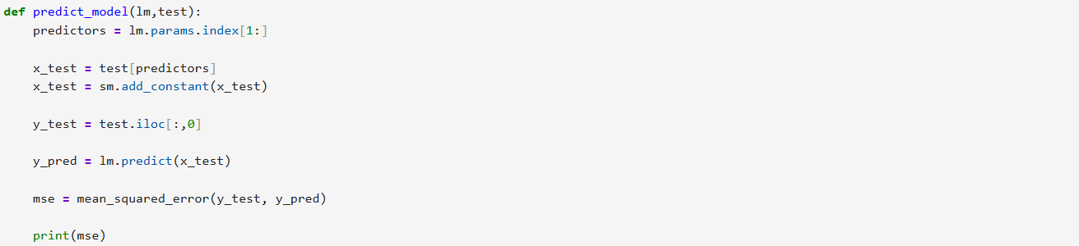
Step 3: Apply function to models 1-5 and present the result
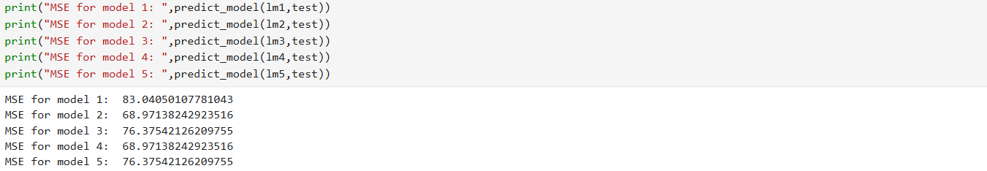
7. Compare all the regression models that you have constructed by creating a comparison table with the metrics: adjust R-square, AIC, BIC, and predicted MSE.
Model | Adjusted R-square | AIC | BIC | Predicted MSE
1 | 0.755 | 292.0 | 313.9 | 83.0405
2 | 0.760 | 286.5 | 297.5 | 68.9714
3 | 0.758 | 286.9 | 297.9 | 76.3754
4 | 0.760 | 286.5 | 297.5 | 68.9714
5 | 0.758 | 286.9 | 297.9 | 76.3754

Noticed from previous steps, we have two pairs of models that have the same fitted regression lines with the same features, which are model 2&4 and model 3&5. Moreover, the statistics AICs, BICs, and adjusted R-squares are slightly different for each model, indicating that model 2-5 have the almost the same power to explain the response variable Bush. Model 2 and 4 selected the same predictors and achieved the same statistics result, indicating strong agreement between best subset and backward selection. The same happens with model 3 and 5 with the agreement between forward and K-fold selection, but with a slightly different income variable (Inc75 instead of Inc100 like model 2 and 4), making their performance slightly worse than the other two models. Thus, the features combination in model 2&4 is more preferable since it returns lowest Predicted MSE on the test data, giving us to the conclusion of the model with the fitted regression line
Bush = -717.4821 + 60.5757Male – 45.3635Male18 – 1.0359Pop65 + 0.1794NonMet – 1.7905Inc100
will be the best model with significant features that are selected through different methods.

